**NOTE: This is an official document by Indexademics. Unless otherwise stated, this document may not be accredited to individuals or groups other than the club IDX, nor should this document be distributed, sold, or modified for personal use in any way.**

**IDX G9 GEOGRAPHY H STUDY GUIDE ISSUE 5**

**By Ethan S and Heidi**

**Outgassing:** -process in which water and water vapor emerge from the Earth's crust and below

**Eustasy:** -changes in the global sea level caused by changes of water volume in the oceans

**Hydrologic cycle:** -the exchange & flow of all forms of water through Earth's lower atmosphere, hydrosphere, biosphere, and lithosphere

**Evaporation:** -net movement of free water molecules away from a wet surface into air that is less than saturated

**Transpiration:** -when plants release water into the air from stomata in their leaves

**Evapotranspiration:** -made up of evaporation and transpiration over land

**Interception:** -when precipitation lands on vegetation before going into the ground

**Stem flow:** -intercepted water that drains down the stems of plants

**Throughfall:** -precipitation that falls directly to the ground or that drips from leaves

**Infiltration:** -water soaking into the soil

**Overland flow/Surface runoff:** -water that does not soak into the soil and that goes downhill

**Streamflow:** -when overland flow starts to flow in channels

**Percolation:** -water that has already infiltrated into the soil moving downwards

**Soil moisture zone:** -volume of subsurface water stored in the soil that is accessible to plant roots

**Base flow:** -place where water table intersects a stream channel

**Water budget:** -derived from precipitation and soil moisture (if any) - evapotranspiration

**Surplus:** -extra water that remains after expenditure demands are met

**Deficit:** -when precipitation and soil moisture is insufficient to meet demands

**Precipitation:** -moisture supply to Earth's surface

**Potential evapotranspiration:** -amount of water that would evaporate & transpire with optimum moisture conditions

**Actual evapotranspiration:** -potential evapotranspiration - deficit. Gives the amount of water that is actually lost through evapotranspiration.

**Soil moisture storage:** -same as soil moisture zone. Volume of subsurface water stored in the soil that is accessible to plant roots

**Hygroscopic water:** -inaccessible water to plants. Exists in all climates.

**Wilting point:** -when the only water left is inaccessible. Kills off plants

**Capillary water:** -accessible water to plants. Held in soil by surface tension

**Field capacity:** -storage capacity. Maximum amount of water that a specific kind of soil can hold that's available to plants

**Porosity:** -available pore spaces

**Gravitational water:** -water surplus in the soil body after the soil becomds saturated

**Soil moisture utilization:** -usage by plants of the available moisture in the soil

**Soil moisture recharge:** -when water infiltrates the soil and replenishes available water

**Permeability:** -property of the soil that determines the rate of recharge

**Droughts:**

**Meteorological drought:** -defined by degree of dryness compared to the regional average. Region specific.

**Agricultural drought:** -when shortages of precipitation and moisture affect crop yields

**Hydrological drought:** -effects of precipitation shortages on water supply

**Socioeconomic drought:** -when reduced water supply causes the demand for goods/services to exceed it

**Hydropower:** -electricity generated using the power of moving water

**Wetland:** -area that is permanently/seasonally saturated with water

**Groundwater:** -water below the surface

**Zone of aeration:** -layer where soil and rock are less than saturated

**Zone of saturation:** -layer where soil and rock are completely saturated

**Water table:** -point of transition between these two zones

**Aquifer: -** subsurface layer of permeable rock or unconsolidated materials (silt, sand, or gravels) through which groundwater can flow in amounts adequate for wells and springs.

**Aquiclude:** - the impermeable layer of rock below the groundwater.

**Unconfined Aquifer:** - has a permeable layer above and an impermeable layer (aquiclude) below.

**Confined Aquifer:** - has impermeable layers both above and below.

**Potentiometric Surface:** - a pressure level created by the pressure on the water in a confined aquifer.

**Wells:**

- Ordinary Well: drilled into an unconfined aquifer; the water is not under pressure and so does not rise, rather needing to be pumped up.

- Artesian Well: drilled into a confined aquifer; the water rises to the potentiometric surface.

- Gushing Artesian Well: an artesian well whose top is lower than the potentiometric surface, causing the water to rise up out of the well.

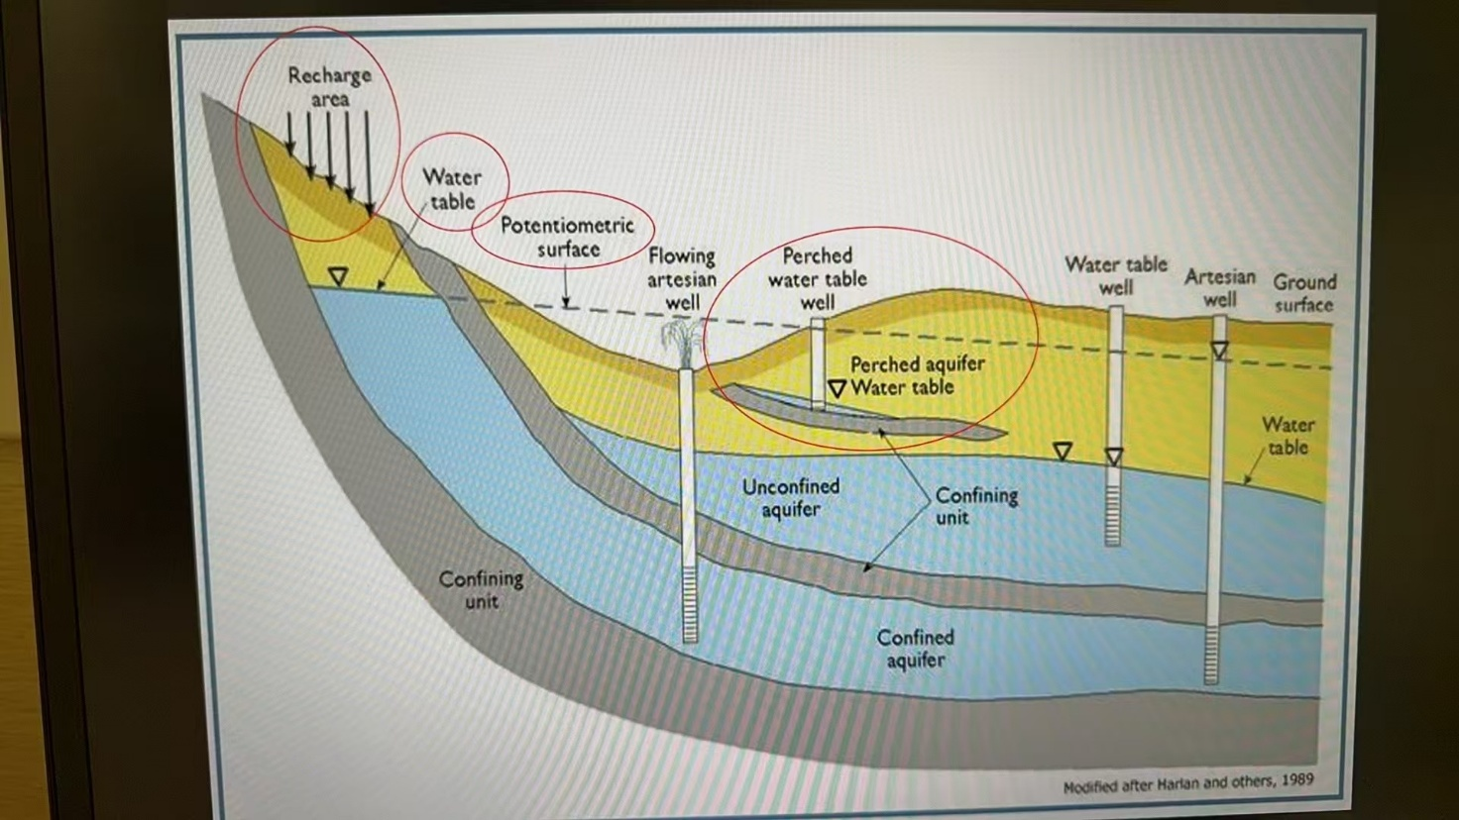

**Drawdown:** - lowering of the water table of an unconfined aquifer; occurs when the rate of pumping water from a well exceeds the rate the water can replenish itself.

**Cone of Depression:** - the lowered water table around the well forms a cone of depression.

**Water Withdrawal (Nonconsumptive Use):** - removal or diversion of water from surface/groundwater supplies followed by the subsequent return of that water to the same supply; e.g. water use by industry, agriculture, and in steam-electric power generation (a portion of the water withdrawn may be consumed but not all).

**Consumptive Use:** - permanent removal of water from the immediate water environment; this water is not returned and so is not available for a second/third use; e.g. water lost to evapotranspiration, consumed by humans/livestock, or used in manufacturing.

**GROUNDWATER CONTAMINATION ARTICLE**

(You only need to know 2-3 of these with examples for short answer!)

**Natural Sources:** - some substances found naturally in rocks or soils (e.g. arsenic, chlorides, iron) can become dissolved in groundwater, and other naturally occurring substances (e.g. decaying matter) can move in groundwater. Some of these substances can pose health threats if consumed excessively, others can bring undesirable odors/tastes/colors.

**Septic Systems:** - outflow from septic tanks, cesspools, and privies can contaminate groundwater. The large number and widespread use of septic systems make them a serious contamination source. Improperly sited, designed, constructed, or maintained septic systems can contaminate groundwater with bacteria, viruses, nitrates, oils, detergents, and chemicals. Septic system cleaners can also contaminate wells. Many regulations require specific distances between septic systems and drinking water wells.

**Improper Disposal of Hazardous Waste:** - hazardous waste should always be disposed of properly. Many chemicals should not be disposed of in household septic systems (e.g. oils, garden chemicals, paint); and many industrial substances should not be disposed of in drains at the workplace they could contaminate drinking water sources. Industries use large varieties and quantities of chemicals, and therefore proper disposal is extremely important.

**Releases and Spills from Stored Chemicals and Petroleum Products:** - storage tanks can leak due to age and corrosion. If an underground storage tank leaks, the contents can travel through the soil and reach the groundwater underneath; abandoned underground storage tanks are also dangerous as their location is often unknown. Leaks of aboveground tanks can also contaminate groundwater if there are no adequate barriers in place. Tanker trucks and train cars also pose hazards if they spill/leak.

**Landfills:** - disposal of hazardous chemicals in municipal landfills and unregulated household waste disposal pose threats. Chemicals leach into the ground through precipitation and surface runoff. If landfills are not sealed/capped correctly, there is also a danger of the chemicals leaching into the ground.

**Surface Impoundments:** - shallow ponds/lagoons that store, treat, and dispose of liquid wastes. Required to have liners, but the liners sometimes leak.

**Sewers and Other Pipelines:** - sewer pipes sometimes leak fluids into surrounding soil and groundwater. Pipelines carrying industrial chemicals and oil brine can also leak, especially when the materials being transported are corrosive.

**Pesticides and Fertilizer Use:** - pesticides and fertilizers (some highly toxic) can enter and contaminate groundwater following normal, registered use. (there’s a bunch of data in the article and I don’t want to put it all here so you can go see for yourself)

**Drainage Wells:** - used in wet areas to help drain water and transport it to deeper soils; may contain agricultural chemicals and bacteria.

**Injection Wells/Floor Drains:** - injection wells are used to collect storm water runoff, collect spilled liquids, and dispose of wastes. Floor drain usage by businesses is regulated by the government, and wells that pose potential threats are closed or connected to public sewage systems/storage tanks.

**Improperly Constructed Wells:** - groundwater contamination results when contaminated surface/ground water is introduced into the well.

**Improperly Abandoned Wells:** - contaminants may reach aquifer through these wells is the casing is removed/corroded. Some people dispose of wastes in these wells. These wells may reach into an aquifer.

**Active Drinking Water Supply Wells:** - construction problems (e.g. faulty casings, inadequate covers) allow outside water/contaminants to enter the well.

**Poorly Constructed Irrigation Wells:** - can allow contaminants to enter groundwater; often pesticides and fertilizers are used in immediate vicinity of wells on agricultural land.

**Mining Activities:** - precipitation can leach soluble minerals from mine wastes into groundwater below. Mines are also sometimes pumped to keep them dry; pumping can cause contaminated groundwater to move upward, potentially contaminating wells.

**Effects of Groundwater Contamination (*for everyone!)*:** - can result in poor drinking water quality, loss of water supply, degraded surface water systems, high cleanup costs, high costs for alternative water supplies, and/or potential health problems. Contamination can remain undetected for long periods of time because groundwater moves slowly, making cleanup difficult. Cleanup, if undertaken, can also be costly and expensive. There are many different cleanup strategies and they are selected based on on-site factors. Drinking contaminated water can result in illnesses such as hepatitis, cholera, giardiasis, or methemoglobinemia (“blue baby syndrome”). Benzene, a component of gasoline, is a human carcinogen.

**Regulations to Protect Groundwater:** - (a lot of acts and organizations that I won’t list so you can read it yourself)

**WATER DESALINATION ARTICLE**

Environmental concerns of water desalination include trapping and killing sea life, which negatively affects the marine ecosystem of the area where seawater is drawn in. Subsurface intakes fix this problem by drawing water from beneath dunes, far away from any sea life.

Another environmental concern can include how the brine left over after the desalination process is disposed of. If dumped straight into the ocean, it can kill off organisms on the seabed. Proposed solutions to this include spraying it into the ocean or running it through a very long pipe with holes spaced out.

An economic concern of the water desalination process would be the large amount of energy required to pump seawater through membranes to filter out the salt, since a lot of pressure is needed — one solution to this is to power the plant using renewable energy sources (using methane from a landfill is mentioned in the article)